**553/3 BIOLOGY**

1. You are provided with specimen B which is a plant organ, examine it and answer the questions that follow.
2. (i) Identify the specimen

Stem tuber (01mk)

(ii) State the functions of the specimen giving a reason for each function

|  |  |
| --- | --- |
| Function | Reason |
| Vegetative reproduction\  propagation | Lateral buds; |
| Food storage; | Swollen  04mks |

(04 marks)

(b) Carry out experiments on solution B1 and state its identity.

|  |  |  |
| --- | --- | --- |
| TEST | OBSERVATION | DEDUCTION |
| 1 | Yellow; suspension;/white  Suspension turns to a blue-black \purple; solution; | Starch is present  (03mks) |
| 2 | Yellow suspension/white suspension turns to a clear solution to a purple/violet solution | Proteins present.  (04 mks) |
| 3 | Deep blue Solution remains a blue solution | Ascorbic\vitamin C absent  (03 mks) |

(10 marks)

c) (i) Identify the food(s) present

Proteins, and starch, (01 mark)

(ii) Explain the relevancy of the food(s) in relation to the functions you stated in a (ii) above

(03marks)

Starch and proteins are used for the development of new plants, from the lateral buds.

(2) You are provided with specimens K, L, M and N. Examine them and answer the questions that follow.

Open specimen K, L,and N longitudinally

(a) Describe the structure features of the specimens. (06 marks)

**pecimen K**

Many seeds, fleshly pericap, juicy endocarp, thin epicarp, short pericarp, axile placenta, 2 scars.

**Specimen L**

Many several seeds, dry\hard pericarp, ported apex, long pericarp, maginal placenta, 2 scars

**Specimen M**

Fleshy mesocarp\epicarp, hard\ (fibrons endocarp for mango) thick epicarp\mesocarp\thin       endocarp, 2 scars one seed.

**Specimen N**

Hairy persistent calyx, short pericarp, dry pericarp, 2 scars

Any 3 for each mark (06mks)

(b) Using the structural features stated above in 2(a) construct a dichotomous key to identify the specimens K, L, M and N. (06 Marks)

1a, Has hairy persistent calyx………………………………………………..Specimen N

b Has No calyx……………………………………………………………..go to 2,

2a,Has many seeds……………………………………………………………..go to 3

2b, Has one seed………………………………………………………………..specimen M

3a, Has axile placenta…………………………………………………………..Specimen K

b, Has marginal placenta…………………………………………………….....Specimen L

(c) Describe the arrangement of seeds in L and M. (03 marks)

**Specimen L**

Many seeds are attached to the placenta, along the margin of fruit wall. (02mks)

**Specimen M**

One large seed in the Centre of the fruit, attached to a placenta at the base of the fruit. (02 mks)

(d) Hold specimen N above your head and release it.

State your observation and give the significance of your observation. (3 marks)

It floats in air

It implies that it can easily be blown by wind and be scattered away from the parent plant, I dispersed by wind. (01mk)

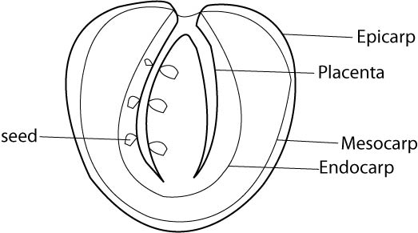 (e) Make a large labeled drawing of one half of specimen K. State your magnification.

(06 marks)

Drawing points

* Well drawn seed (actual shape) T 01
* Well drawn epicarp(thin) b 02
* Well drawn mesocarp(thicker) L 01
* Magnification range x x 3 M 01

A

N0

Total = 21 marks 06 marks

3. You are provided with specimen R and S which belong to the same phylum.

(a) State the phylum to which they belong giving 2 reasons for your answer.

phylum Arthropoda

Have segmented bodies

Have jointed legs

Have exo skeleton.

Any 2 a mark (02mks)

1. Examine the head regions of the specimens and describe the mandibles, eyes and antennae of each specimen.

|  |  |  |  |
| --- | --- | --- | --- |
| SPECIMEN | MANDIBLES | EYES | ANTENNAE |
| R | Hard, pointed,  a pair | No eyes | a pair, short,  segmented |
| S | Hard, serrated  a pair | a pair of large, comma  shaped, compound | a pair of long segmented, tapering at distal end |

(06 marks)

c) State the functions of the mandibles in each specimen and state how they are adapted for their functions

**Specimen R**

For protection, mark

* Pointed for piercing 01mark

**Specimen S**

For Feeding, mark

- Serrated for cutting food into small pieces; 01 mark

(d) Suggest the habitat of specimen S and state 2 characteristics that suit it to survive in the habitat. (03 marks)

Habitat: Cracks /Crevices/dark places;

Characteristics

- Dorsal-ventral flattering to fit into cracks and crevices.

- Dull colour for camonflaging. 03 marks

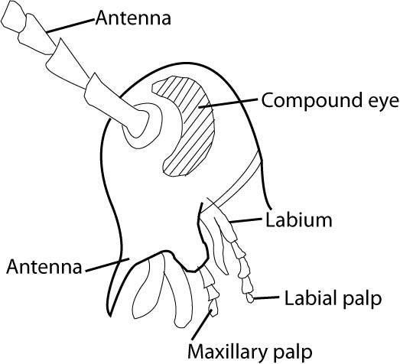(e) Make a large labeled drawing of the lateral view of the head region of specimen S and state your magnification. (06 marks)

***Drawing points***

* Segmented antenna
* Comma shaped compound eye
* Segmented labial palp\maxillary palp

*T*

*D 2*

L 1()

M 01

A

N 06 marks